Chapter 19, Problem 73.

Three copies of the circuit shown in Fig. 19.70, are connected in cascade. Determine the z parameters.
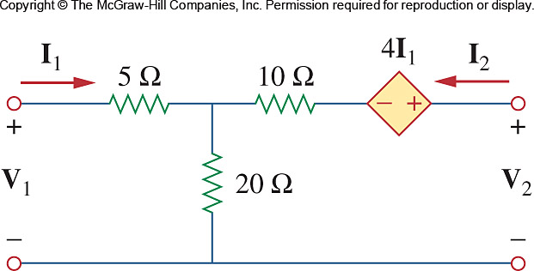

Figure 19.70
For Probs. 19.6 and 19.73.

